**Python - Database Access**

Data input and generated during execution of a program is stored in RAM. If it is to be stored persistently, it needs to be stored in database tables. There are various relational database management systems (RDBMS) available.

* GadFly
* MySQL
* PostgreSQL
* Microsoft SQL Server
* Informix
* Oracle
* Sybase
* SQLite
* and many more...

In this chapter, we shall learn how to access database using Python, how to store data of Python objects in a SQLite database, and how to retrieve data from SQLite database and process it using Python program.

Relational databases use SQL (Structured Query Language) for performing INSERT/DELETE/UPDATE operations on the database tables. However, implementation of SQL varies from one type of database to other. This raises incompatibility issues. SQL instructions for one database do not match with other.

To overcome this incompatibility, a common interface was proposed in PEP (Python Enhancement Proposal) 249. This proposal is called DB-API and requires that a database driver program used to interact with Python should be DB-API compliant.

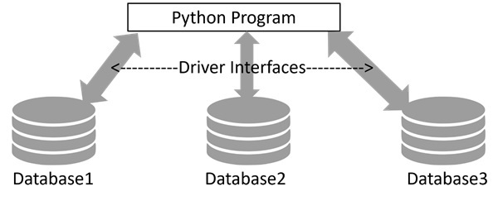

Python's standard library includes sqlite3 module which is a DB_API compatible driver for SQLite3 database, it is also a reference implementation of DB-API.

Since the required DB-API interface is built-in, we can easily use SQLite database with a Python application. For other types of databases, you will have to install the relevant Python package.

|  |  |
| --- | --- |
| **Database** | **Python Package** |
| Oracle | cx_oracle, pyodbc |
| SQL Server | pymssql, pyodbc |
| PostgreSQL | psycopg2 |
| MySQL | MySQL Connector/Python, pymysql |

A DB-API module such as sqlite3 contains connection and cursor classes. The connection object is obtained with connect() method by providing required connection credentials such as name of server and port number, and username and password if applicable. The connection object handles opening and closing the database, and transaction control mechanism of committing or rolling back a transaction.

The cursor object, obtained from the connection object, acts as the handle of the database when performing all the CRUD operations.